1.
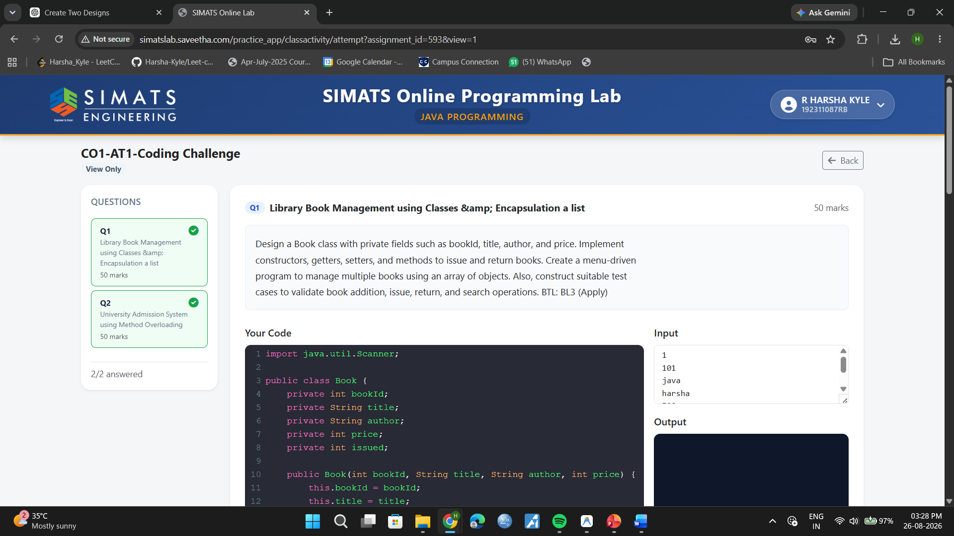
import java.util.Scanner;
public class Book {
private int bookId;
private String title;
private String author;
private int price;
private int issued;
public Book(int bookId, String title, String author, int price) {
this.bookId = bookId;
this.title = title;
this.author = author;
this.price = price;
this.issued = 0;
}
public int getBookId() {
return bookId;
}
public void issueBook() {
if (issued == 0) {
issued = 1;
System.out.println("Issued: " + title);
} else {
System.out.println("Already issued: " + title);
}
}
public void returnBook() {
if (issued == 1) {
issued = 0;
System.out.println("Returned: " + title);
} else {
System.out.println("Not issued: " + title);
}
}
public void display() {
String s = (issued == 1) ? "Issued" : "Available";
System.out.println(bookId + " " + title + " " + author + " " + price + " " + s);
}
static Book[] books = new Book[100];
static int count = 0;
static void addBook(Scanner sc) {
int id = Integer.parseInt(sc.nextLine());
String t = sc.nextLine();
String a = sc.nextLine();
int p = Integer.parseInt(sc.nextLine());
books[count++] = new Book(id, t, a, p);
System.out.println("Book added.");
}
static Book search(int id) {
for (int i = 0; i < count; i++) {
if (books[i].getBookId() == id) return books[i];
}
return null;
}
public static void main(String[] args) {
Scanner sc = new Scanner(System.in);
int choice;
do {
System.out.println("1.Add 2.Display 3.Issue 4.Return 5.Search 6.Exit");
choice = Integer.parseInt(sc.nextLine());
if (choice == 1) {
addBook(sc);
} else if (choice == 2) {
for (int i = 0; i < count; i++) books[i].display();
} else if (choice == 3) {
Book b = search(Integer.parseInt(sc.nextLine()));
if (b != null) b.issueBook();
else System.out.println("Not found");
} else if (choice == 4) {
Book b = search(Integer.parseInt(sc.nextLine()));
if (b != null) b.returnBook();
else System.out.println("Not found");
} else if (choice == 5) {
Book b = search(Integer.parseInt(sc.nextLine()));
if (b != null) b.display();
else System.out.println("Not found");
} else if (choice == 6) {
System.out.println("Exiting.");
} else {
System.out.println("Invalid.");
}
} while (choice != 6);
}
}2

2.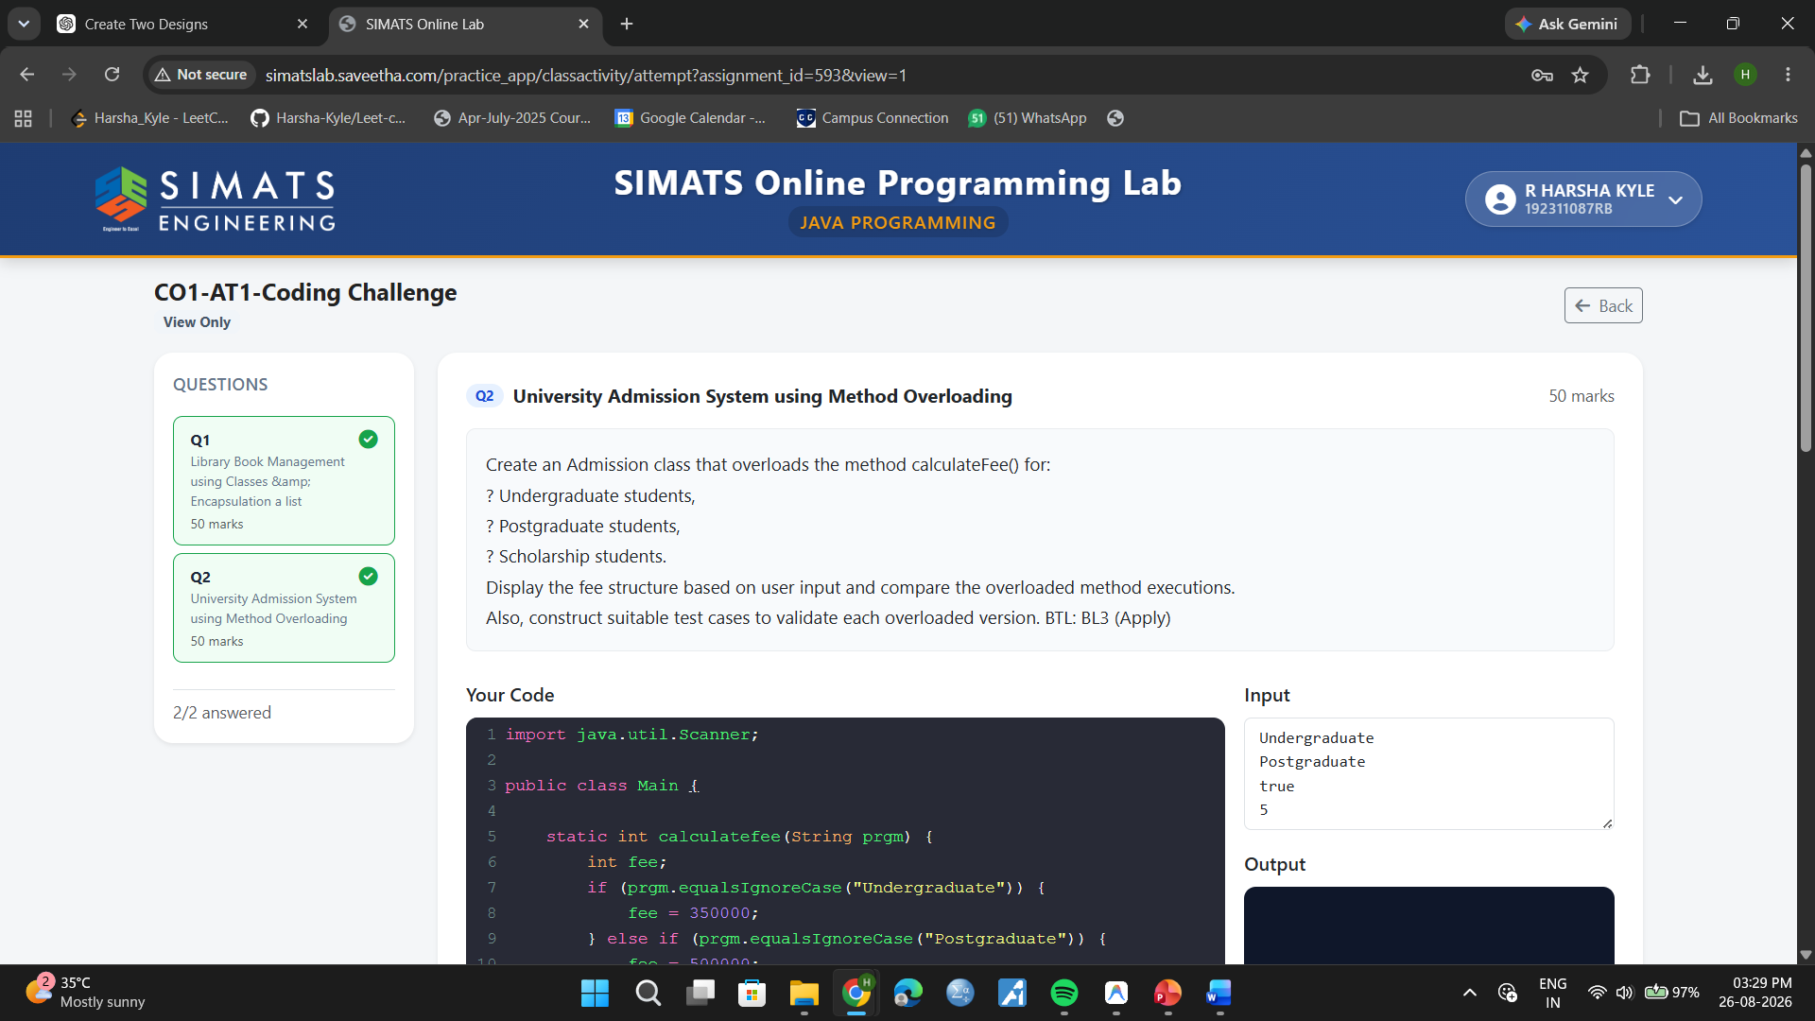
import java.util.Scanner;
public class Main {
static int calculatefee(String prgm) {
int fee;
if (prgm.equalsIgnoreCase("Undergraduate")) {
fee = 350000;
} else if (prgm.equalsIgnoreCase("Postgraduate")) {
fee = 500000;
} else {
fee = 0;
}
return fee;
}
static int calculatefee(String prgm, boolean sch) {
int fee;
if (prgm.equalsIgnoreCase("Undergraduate")) {
if (sch) {
fee = 350000;
} else {
fee = 500000;
}
} else if (prgm.equalsIgnoreCase("Postgraduate")) {
if (sch) {
fee = 350000;
} else {
fee = 500000;
}
} else {
fee = 0;
}
return fee;
}
static int calculatefee(int sem) {
int oneSemFee = 120000;
return sem * oneSemFee;
}
public static void main(String[] args) {
Scanner sc = new Scanner(System.in);
System.out.println("Enter Program Type (Undergraduate/Postgraduate):");
String p1 = sc.nextLine();
System.out.println("Fee is: " + calculatefee(p1));
System.out.println("Enter Program Type (Undergraduate/Postgraduate):");
String p2 = sc.nextLine();
System.out.println("Scholarship (true/false):");
boolean s = sc.nextBoolean();
System.out.println("Fee is: " + calculatefee(p2, s));
System.out.println("Enter Number of Semesters:");
int sem = sc.nextInt();
System.out.println("Fee is: " + calculatefee(sem));
}
}

